**Module No. 1**

**Overview about MikroTik on RouterOS and RouterBOARD**

**I. Topic:**

1.1 Accessing the router and RouterOS command line interface(CLI)

1.2 RouterOS CLI principles and Initial configuration (internet access)

1.3 Upgrading RouterOS and router identity

1.4 Manage RouterOS logins, services and managing configuration backups

**II. Time Frame:** 12 hours

**II. Introduction:**

In this chapter it discusses and provides an introduction and Overview about MikroTik on RouterOS and RouterBOARD

**III. Objectives:**

At the end of the lessons the student can

1. Discuss on how to access the router and RouterOS command line interface (CLI)
2. Discuss the principles of RouterOS CLI
3. Shows the step by step on how to uprade RouterOS and router identity
4. Apply on how to manage RouterOS logins, services and managing configuration backups

**IV. Learning Activities**

*Activity #1: Readings*

The console is used for accessing the MikroTik Router's configuration and management features using text terminals, either remotely using serial port, telnet, SSH, console screen within [WinBox](https://help.mikrotik.com/docs/display/ROS/Winbox), or directly using monitor and keyboard. The console is also used for writing scripts. This manual describes the general console operation principles.

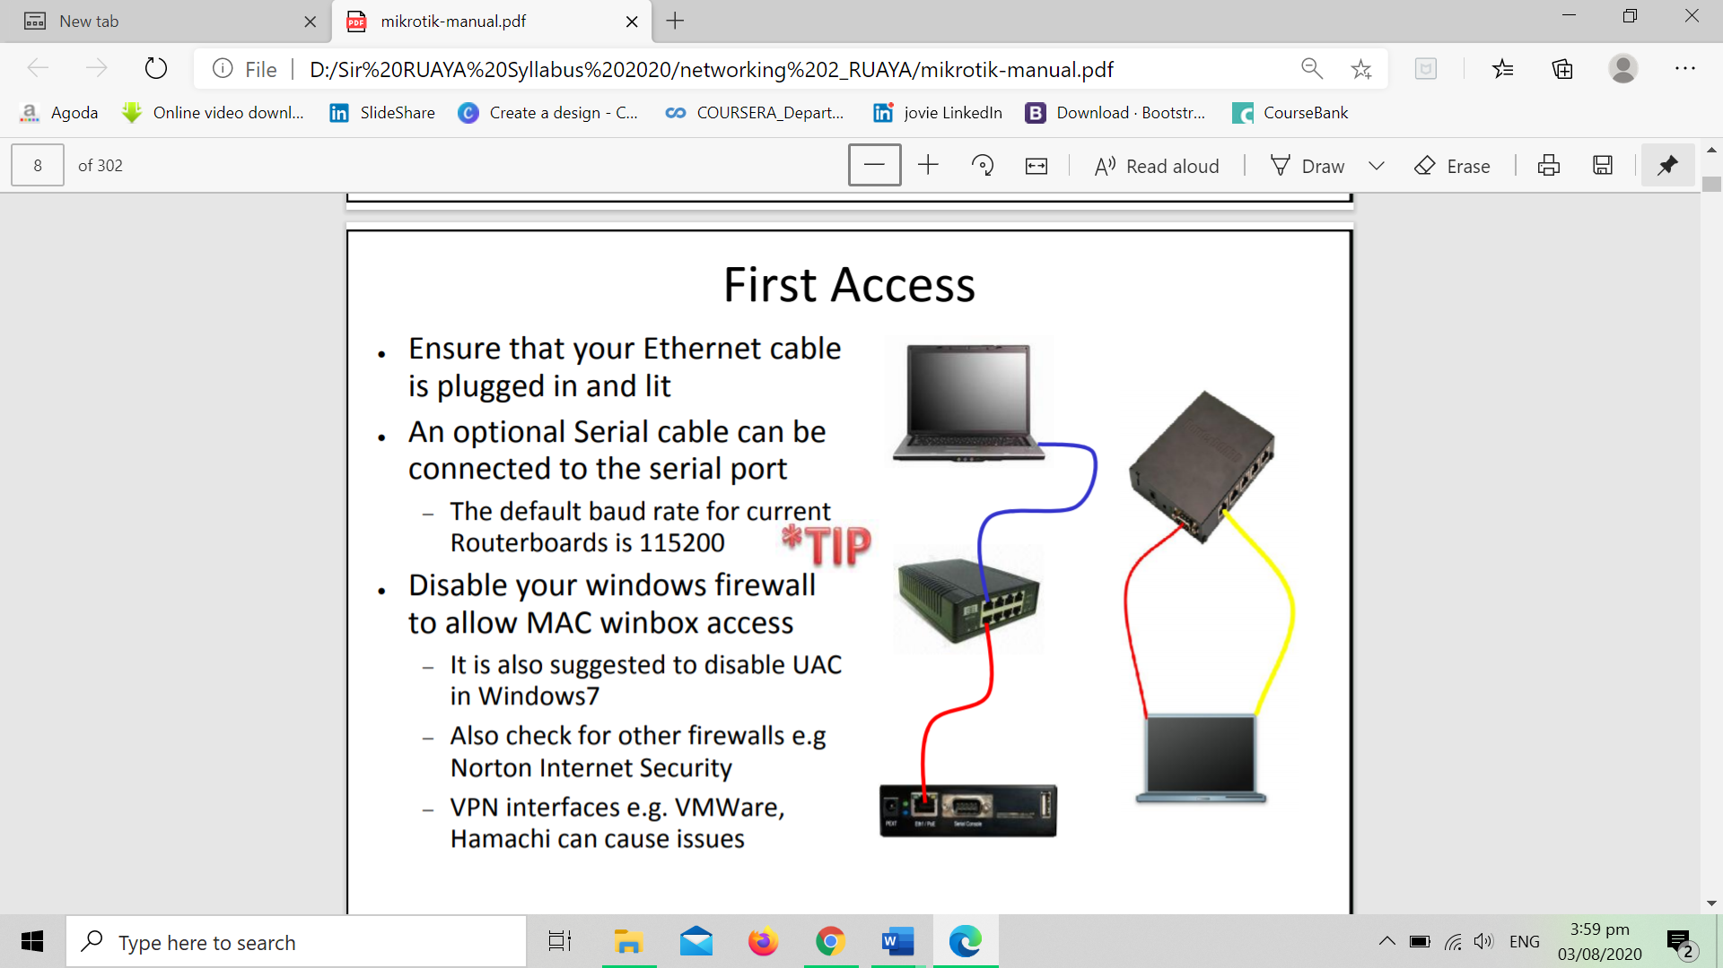

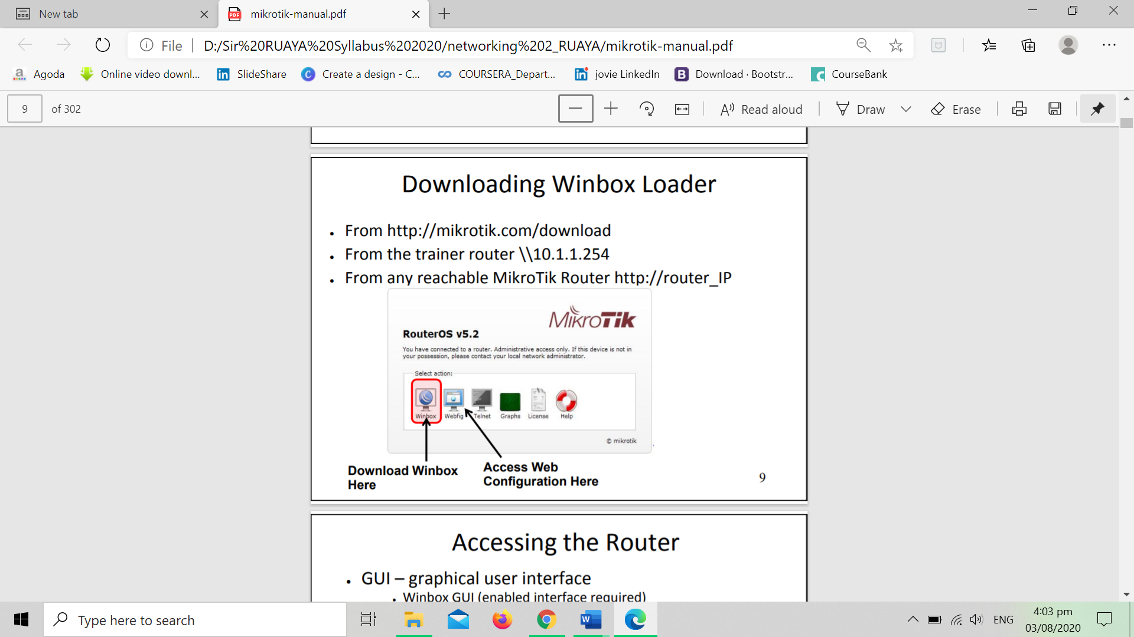

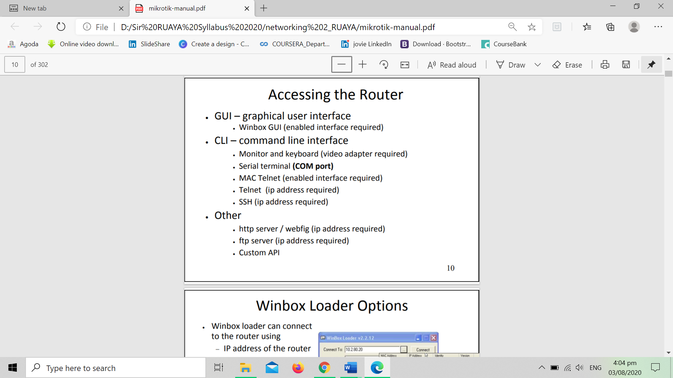

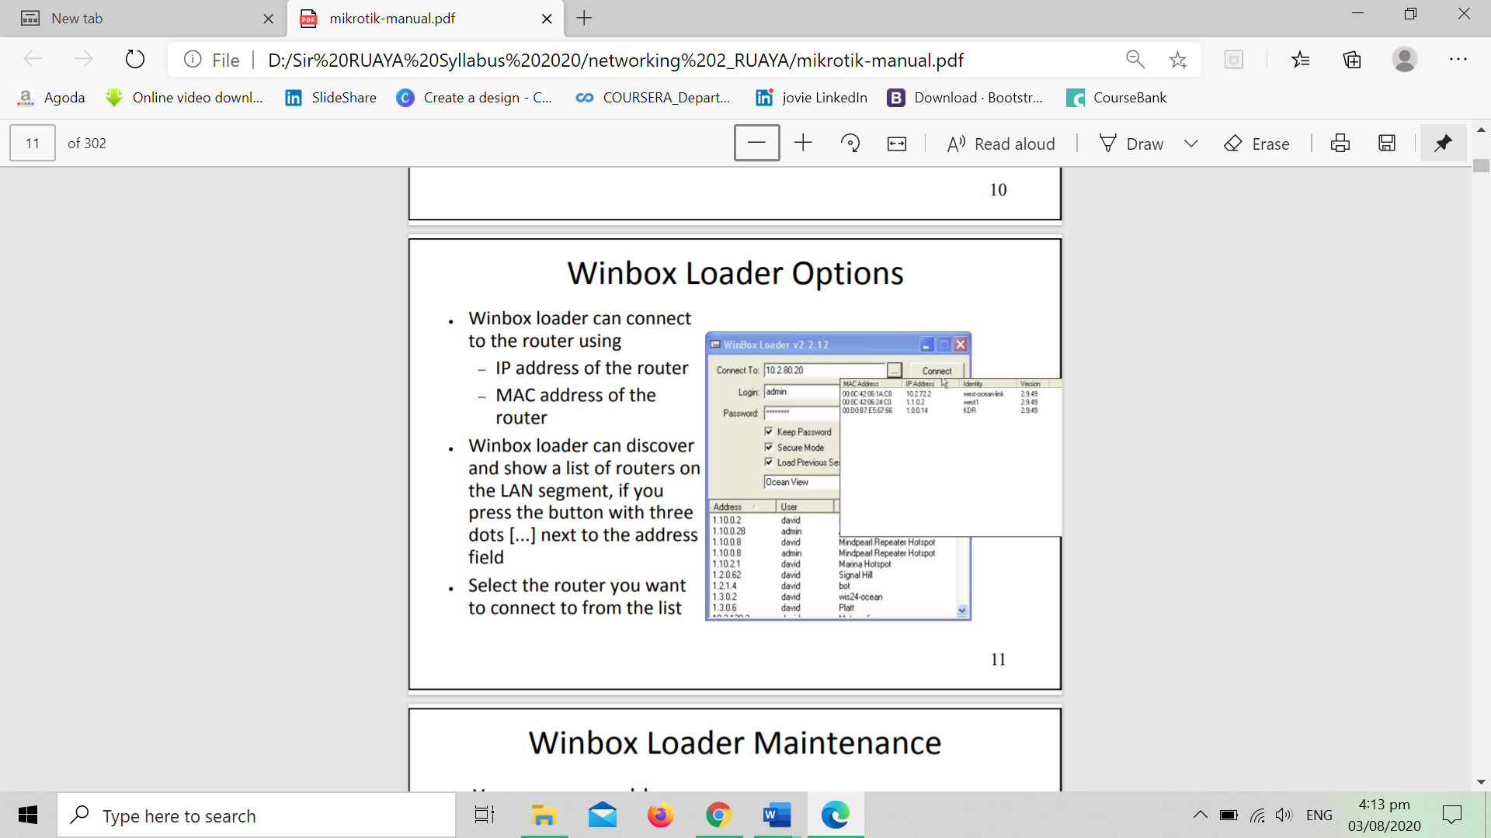

**Starting Winbox**

* **Simple mode**

When you open Winbox loader for the first time simple mode layout will be used:

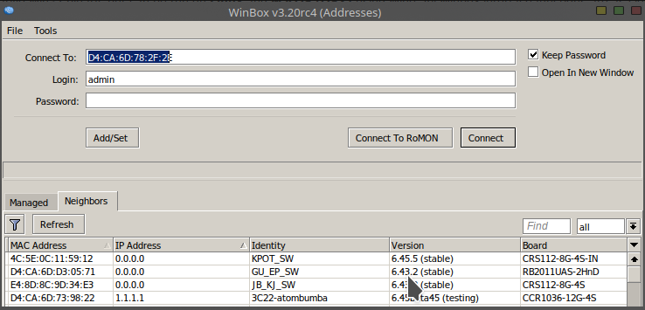

To connect to the router enter IP or MAC address of the router, specify username and password (if any) and click on **Connect** button. You can also enter the port number after the IP address, separating them with a colon, like this 192.168.88.1:9999. The port can be changed in RouterOS **services** menu.

You can also use neighbor discovery, to list available routers use **Neighbors** tab:

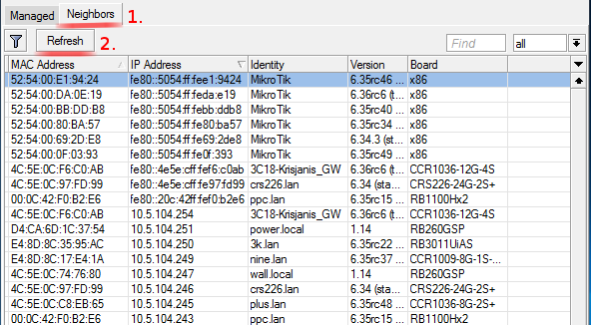

From list of discovered routers you can click on IP or MAC address column to connect to that router. If you click on IP address then IP will be used to connect, but if you click on MAC Address then MAC address will be used to connect to the router.

**Buttons/check-boxes and Other Fields**

* **Connect** - Connect to the router
* **Connect To RoMON** - Connect to [RoMON](https://wiki.mikrotik.com/wiki/Manual:RoMON" \o "Manual:RoMON)Agent
* **Add/set** - Save/Edit any of saved router entries in **Managed** tab.
* **Open In New Window** - Leaves loader open in background and opens new windows for each device to which connection is made.
* **Connect To:** - destination IP or MAC address of the router
* **Login** - username used for authentication
* **Password** - password used for authentication
* **Keep Password** - if unchecked, password is not saved to the list

**Menu Items**

**File**

* + **New** - Create new managed router list in specified location
  + **Open** - Open managed router list file
  + **Save As** - Save current managed router list to file
  + **Exit** - Exit Winbox loader

**Tools**

* + **Advanced Mode** - Enables/Disables advanced mode view
  + **Import** - Imports saved session file
  + **Export** - Exports saved session file
  + **Move Session Folder** - Change path where session files are stored
  + **Clear cache** - Clear Winbox cache
  + **Check For Updates** - Check for updates for Winbox loader

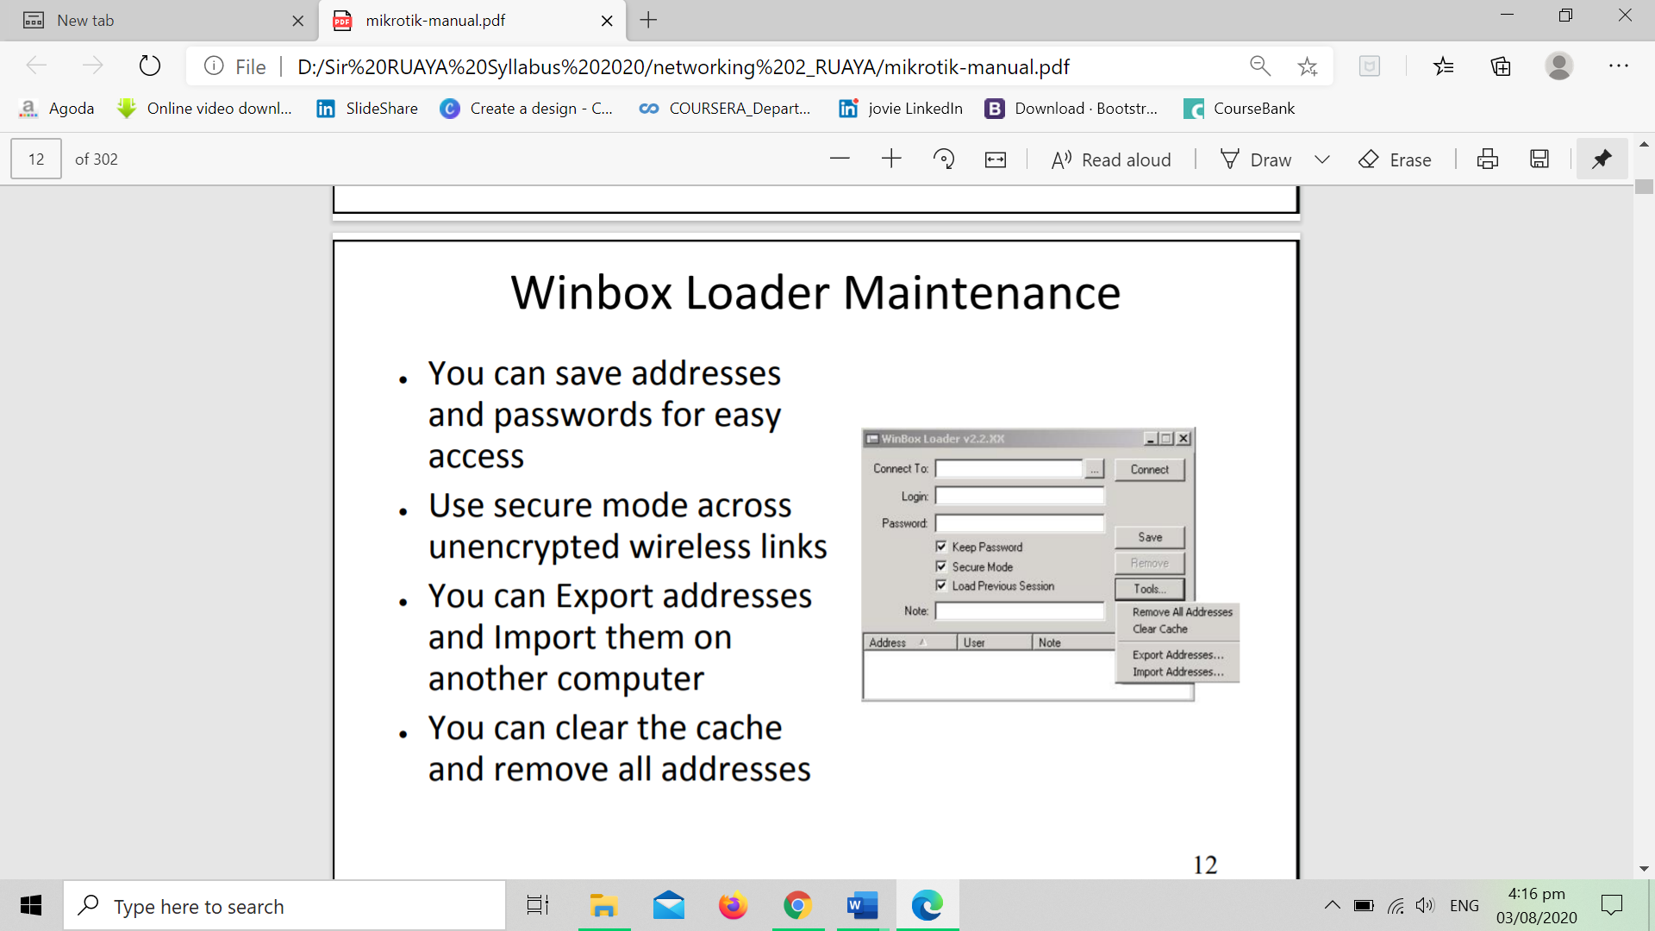

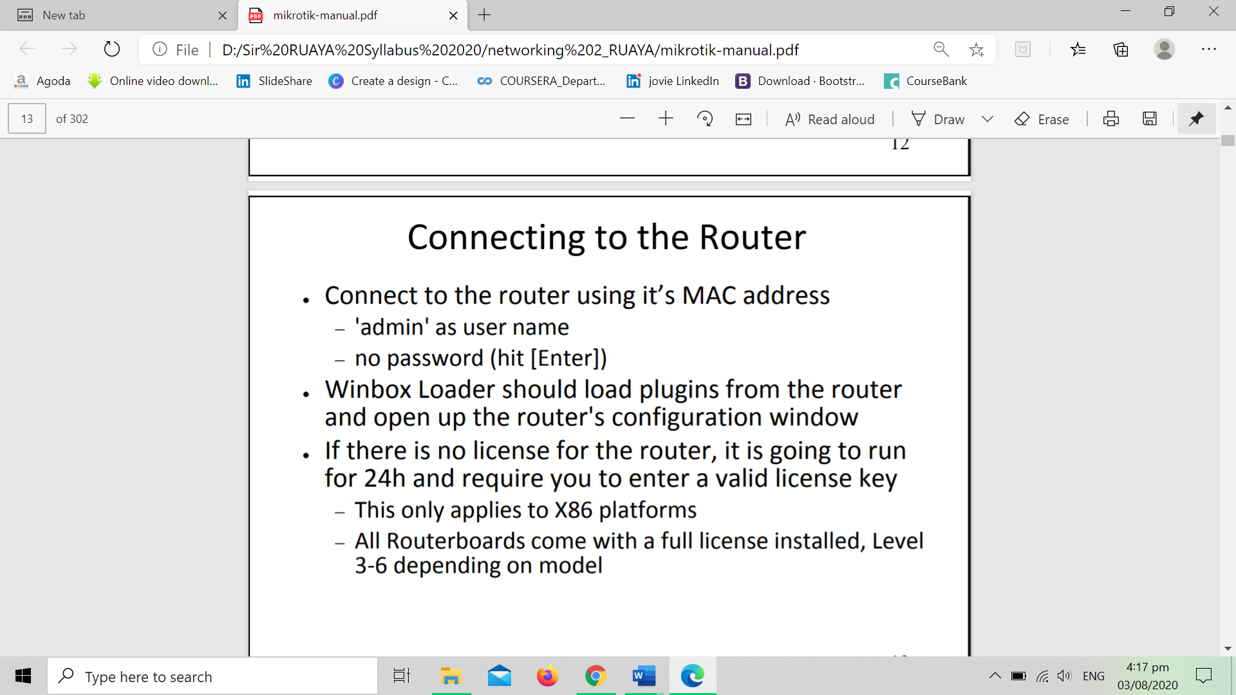

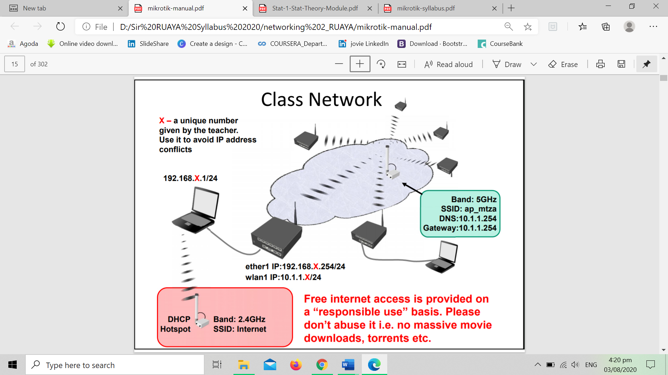

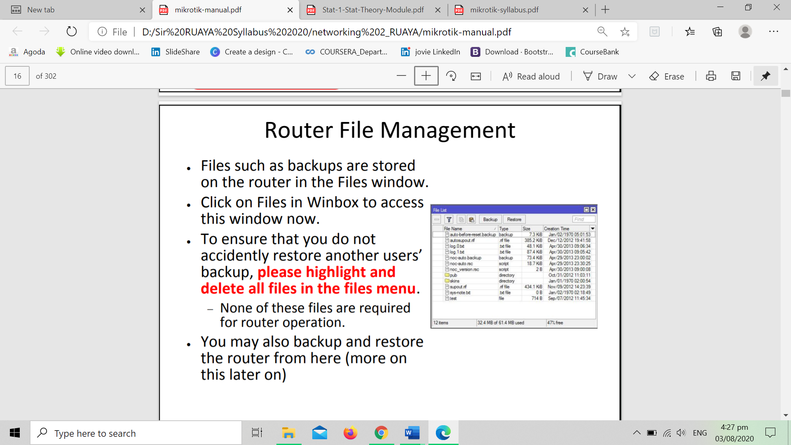

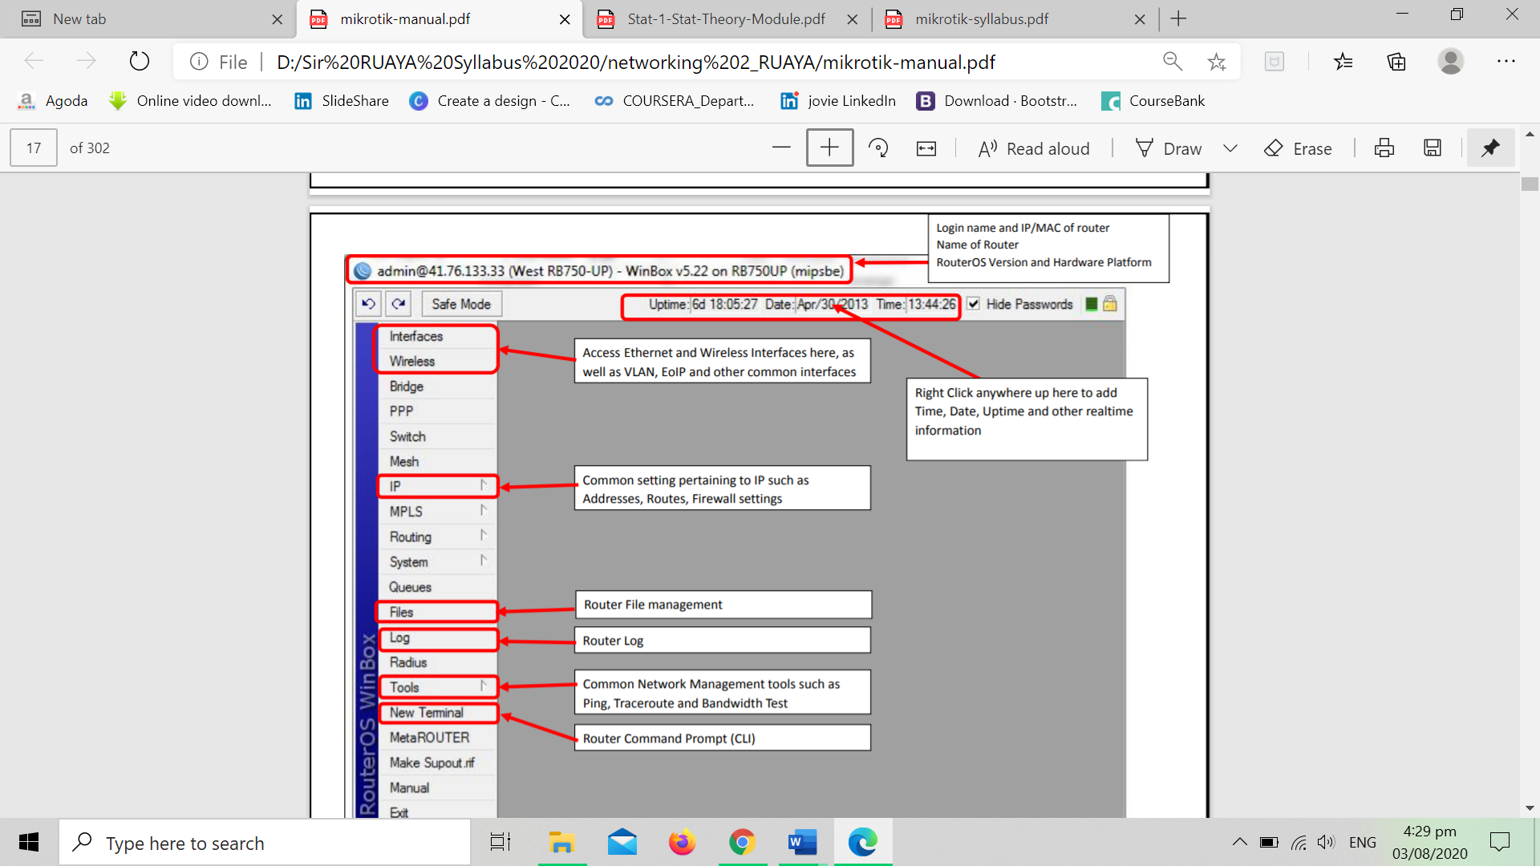

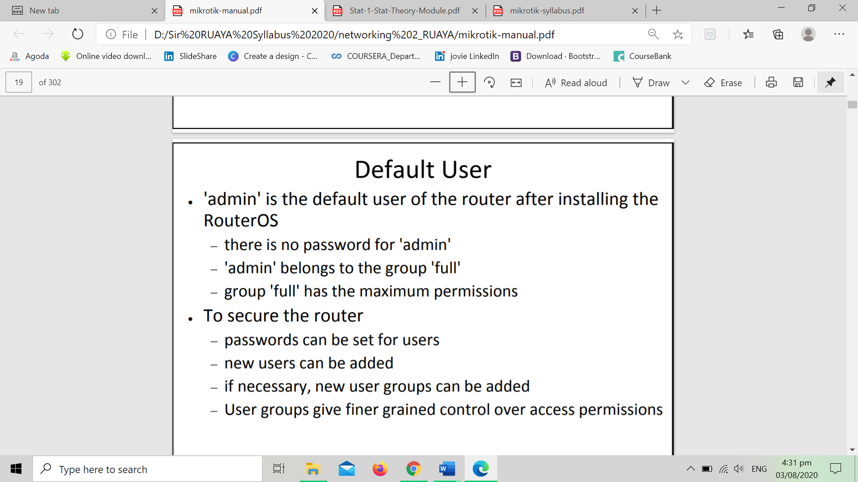

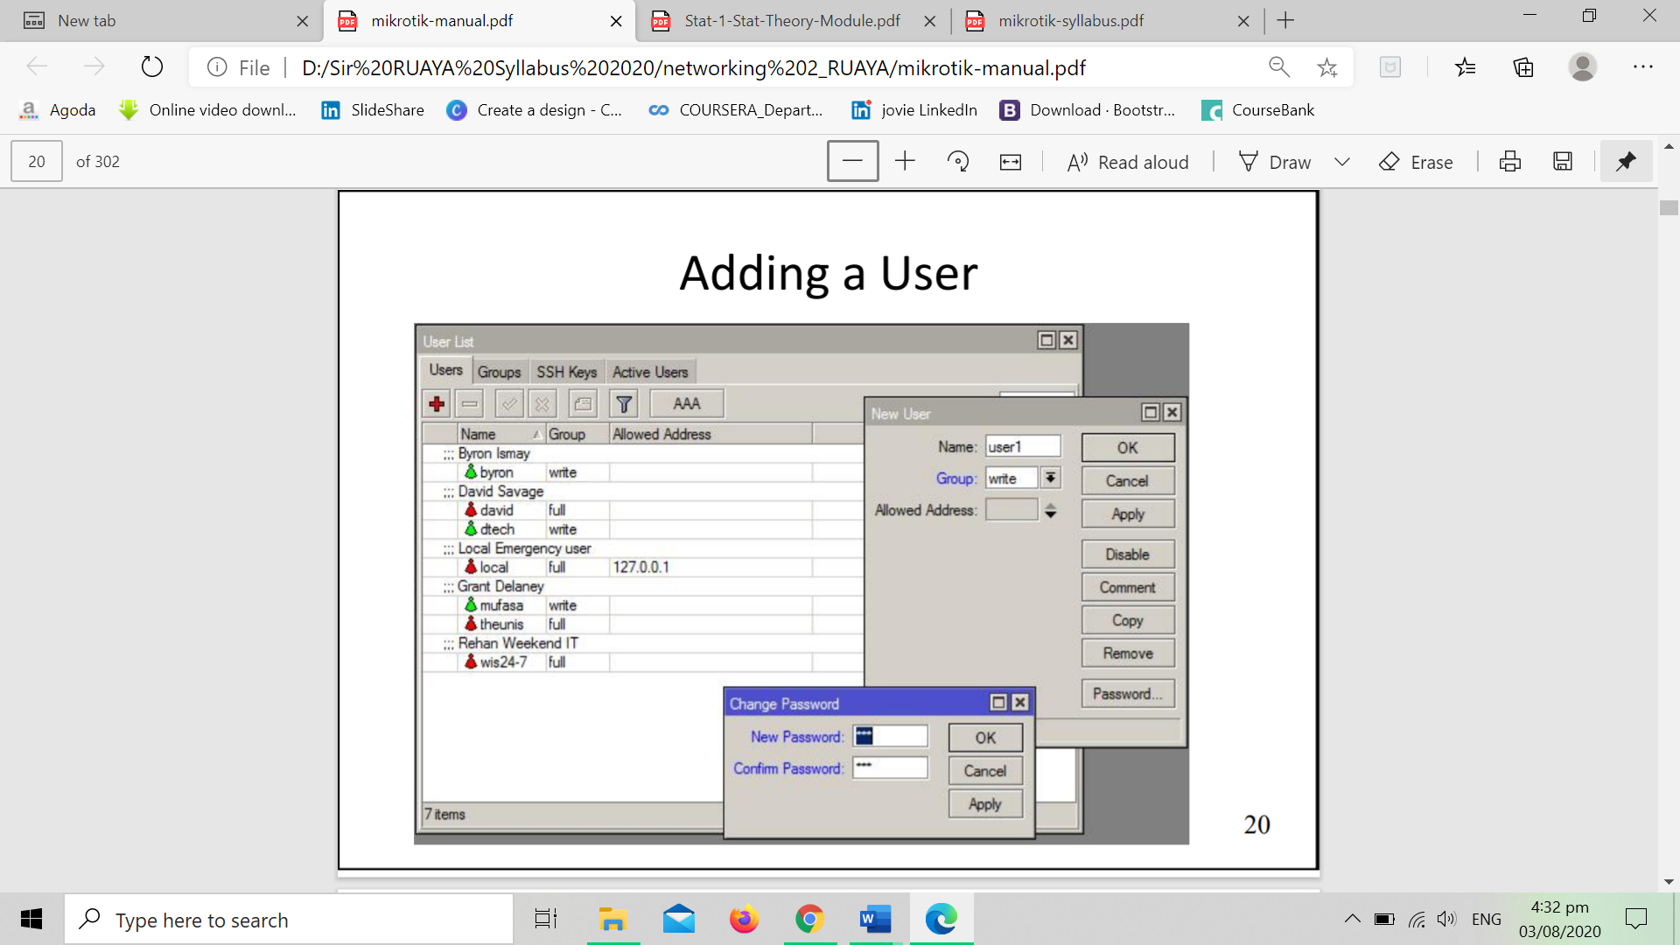

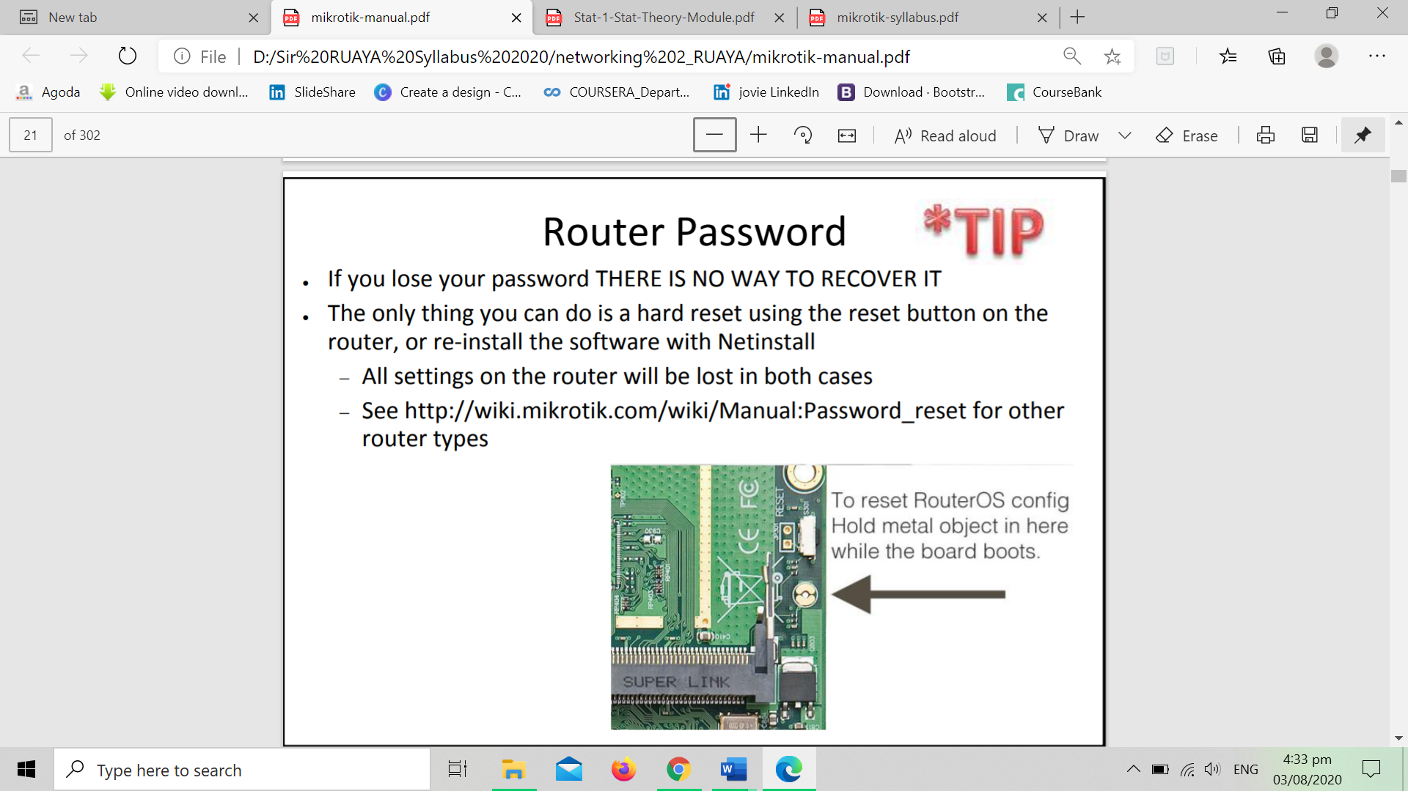

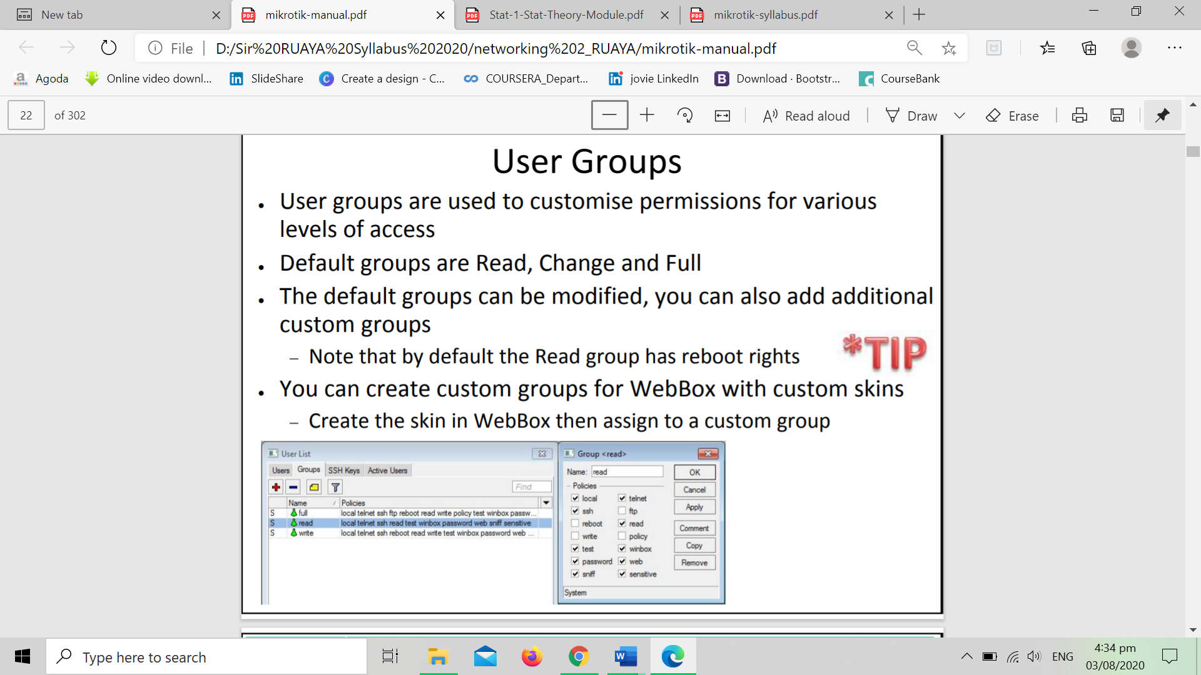

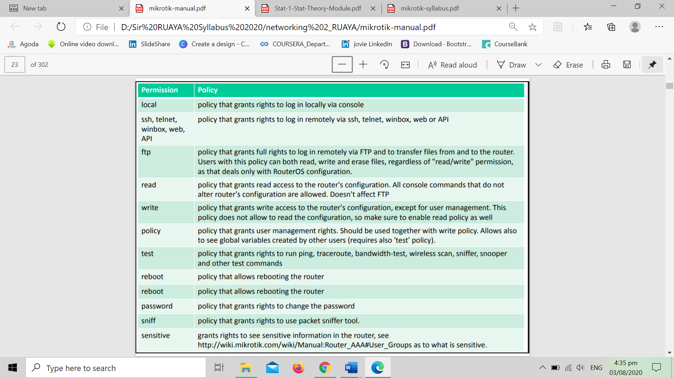

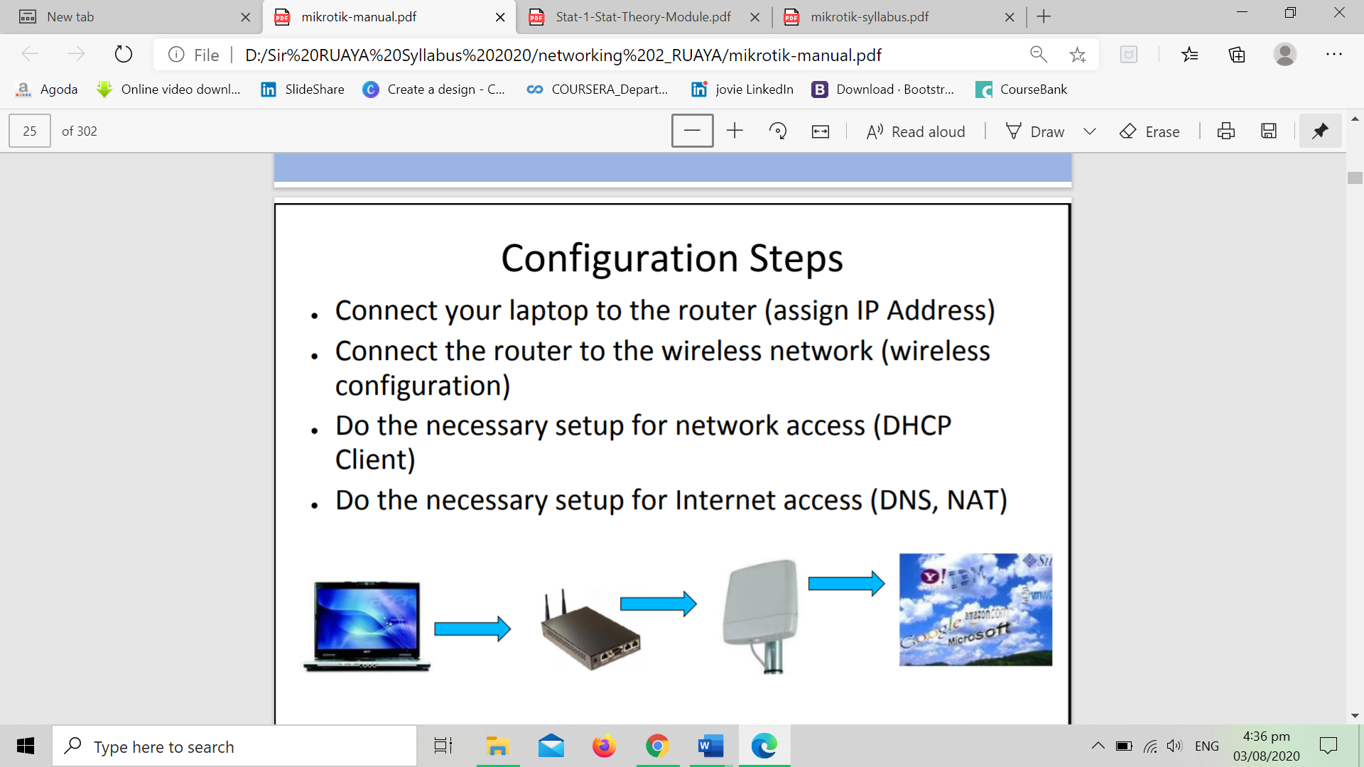

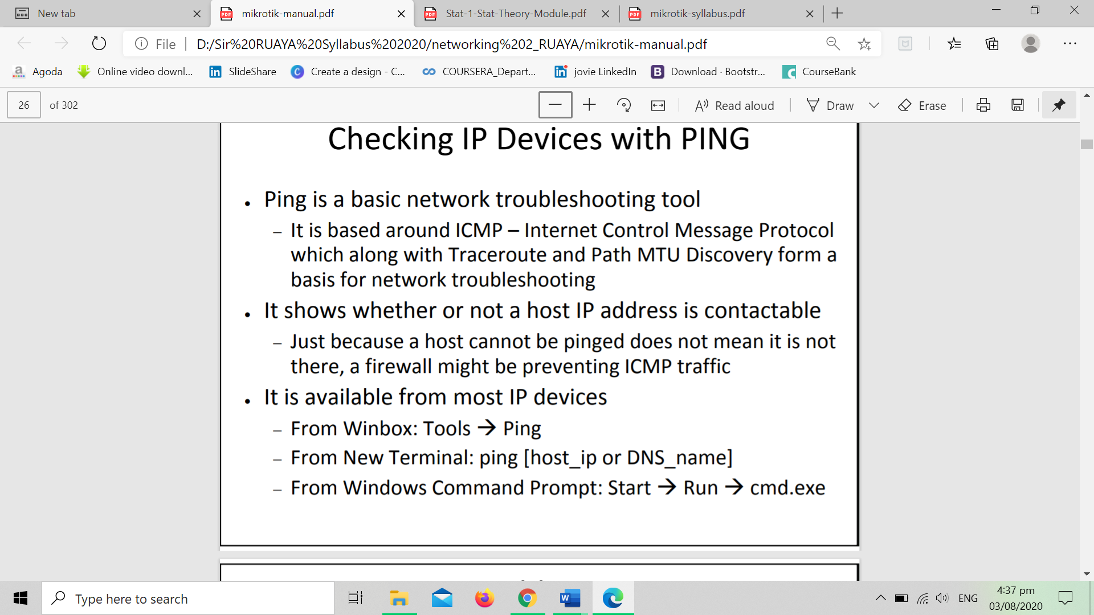

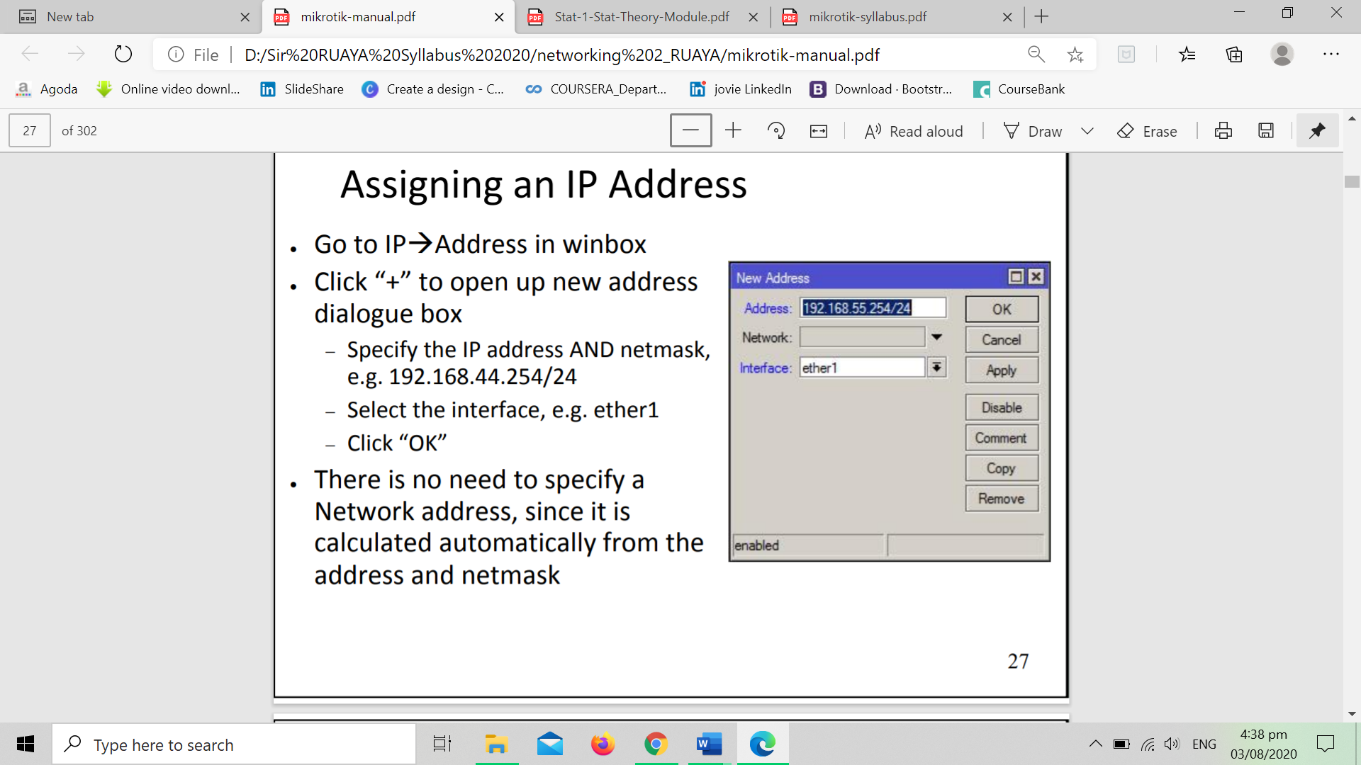

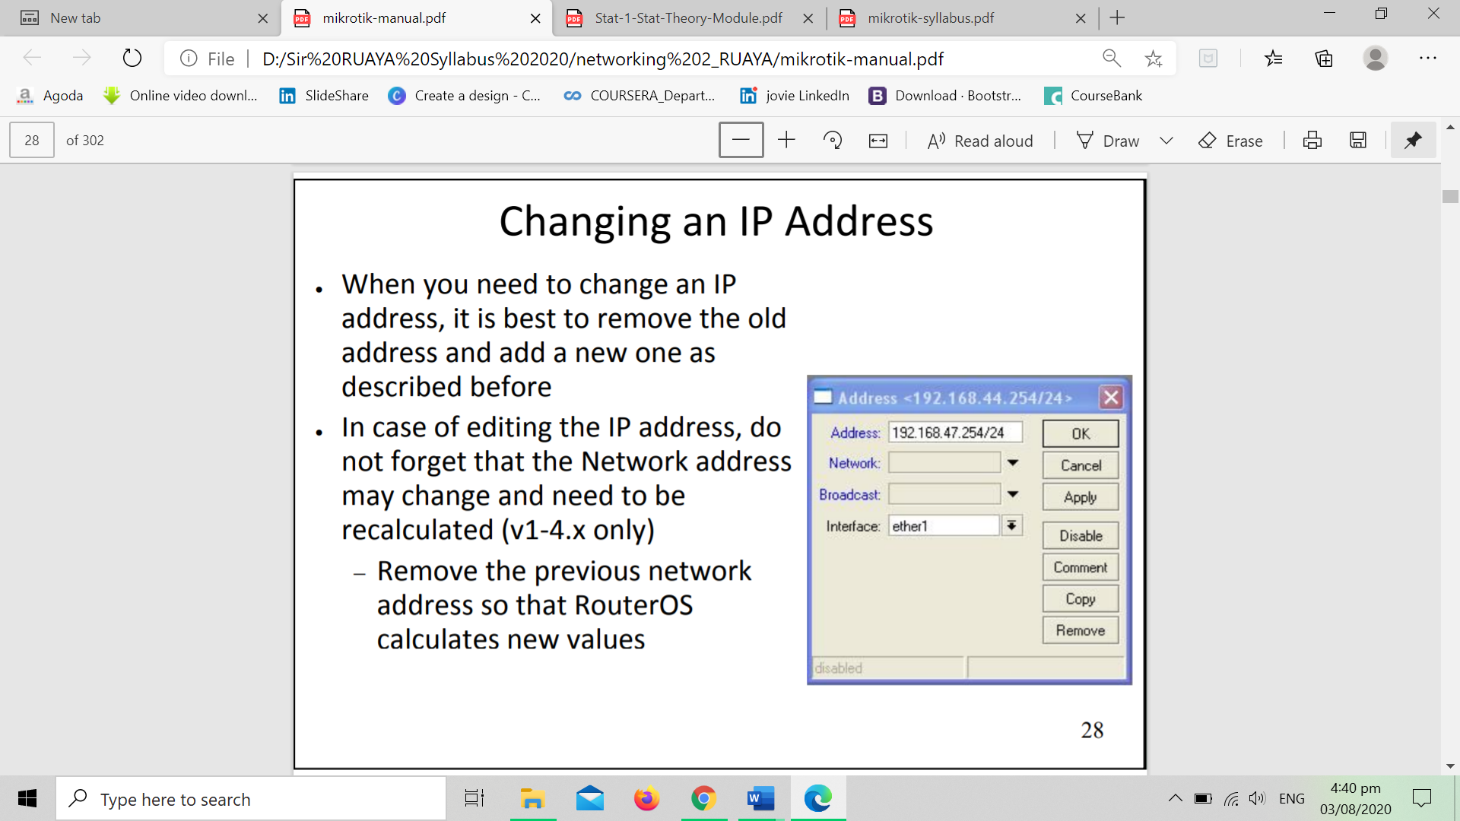

**1.2 RouterOS CLI principles and Initial configuration (internet access)**

## **Configure your computer**

The Commotion software cannot be written directly to the router’s storage via the update system in Mikrotik's RouterOS. So installing Commotion is a two step process:

* First, boot the router from a DHCP server on the local area network. A TFTP server then provides an .ELF firmware file that is loaded into the router's memory.
* Second, a Web server provides a separate firmware file on the local area network for permanent installation.

These server packages must be installed on whatever computer you are installing the Commotion software from. For a guide on installing and running these servers, please see the **[MikroTik Installation Server Setup](https://commotionwireless.net/docs/guides-howtos/installation-server-setup/)**. Read through and perform the necessary steps in those instructions before coming back to this document and proceeding with the installation.

**Setup the Hardware**

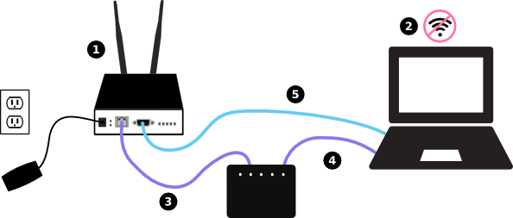

1. Unpack the MikroTik router and install the external antennas (if the unit has them).
2. Turn off your computer’s Wi-Fi, if it is on.
3. Plug in one Ethernet cable to the Switch, then plug that cable into your computer’s Ethernet port.
4. Plug in a second Ethernet cable between the Switch and the Ethernet port on the MikroTik router.
5. Plug in the USB-to-Serial adapter to your computer, and connect the DB-9 connector to the Serial Console port on the MikroTik router.

Don’t plug in the router yet - there are a few more setup steps.

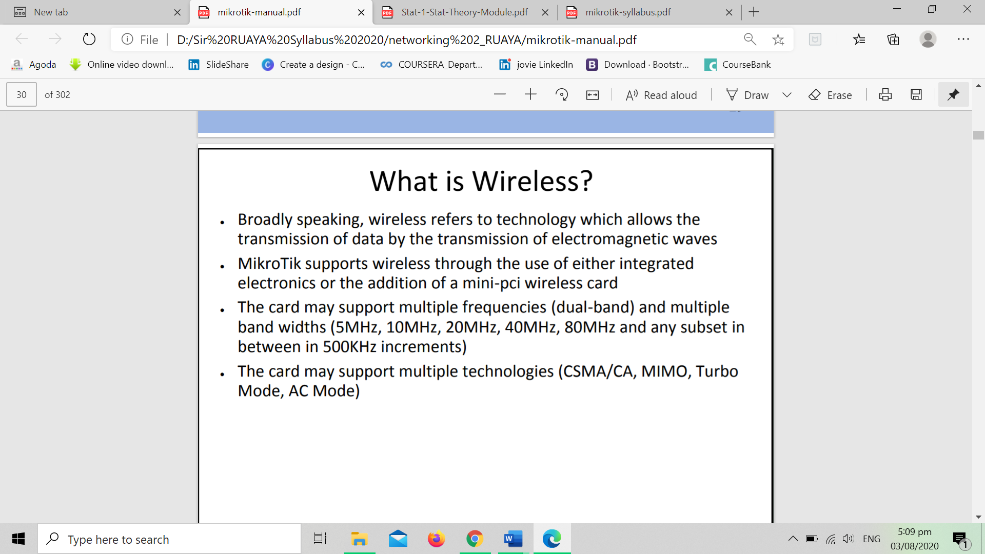

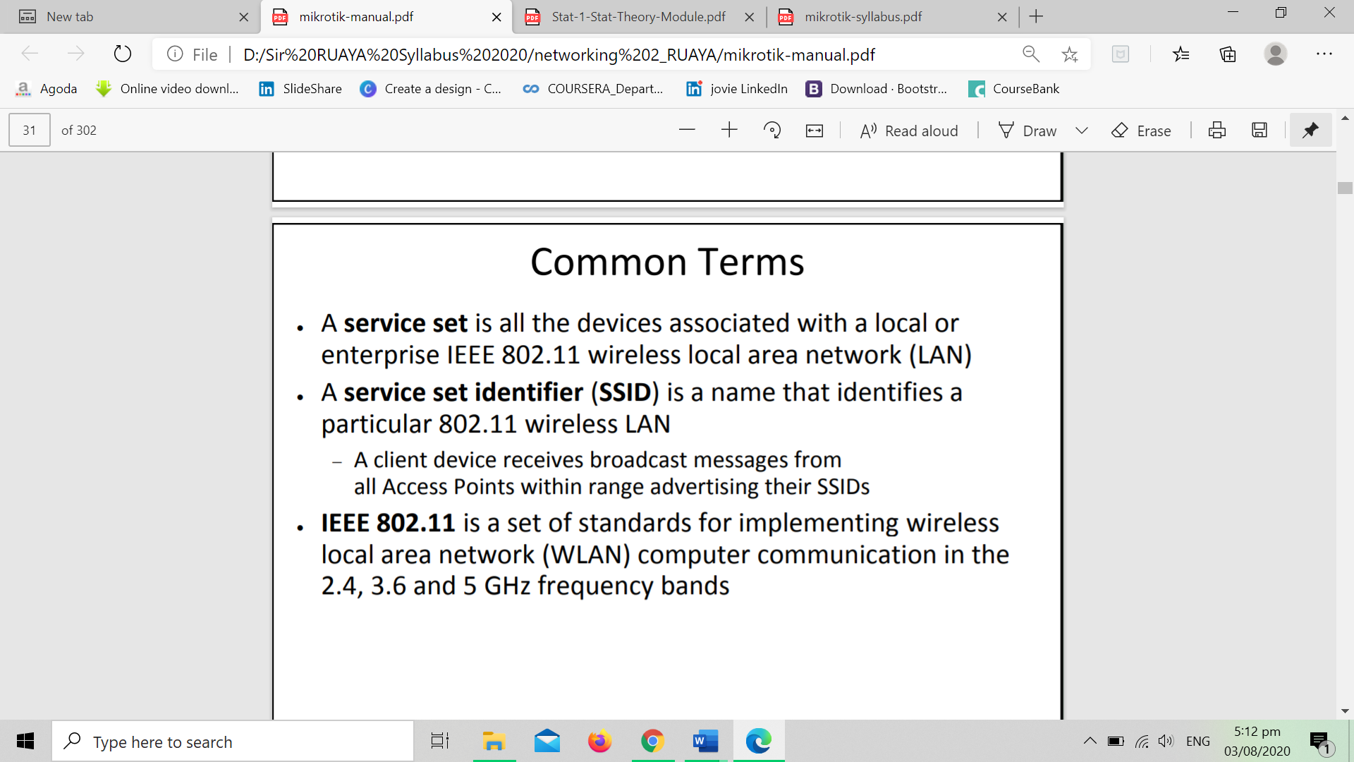

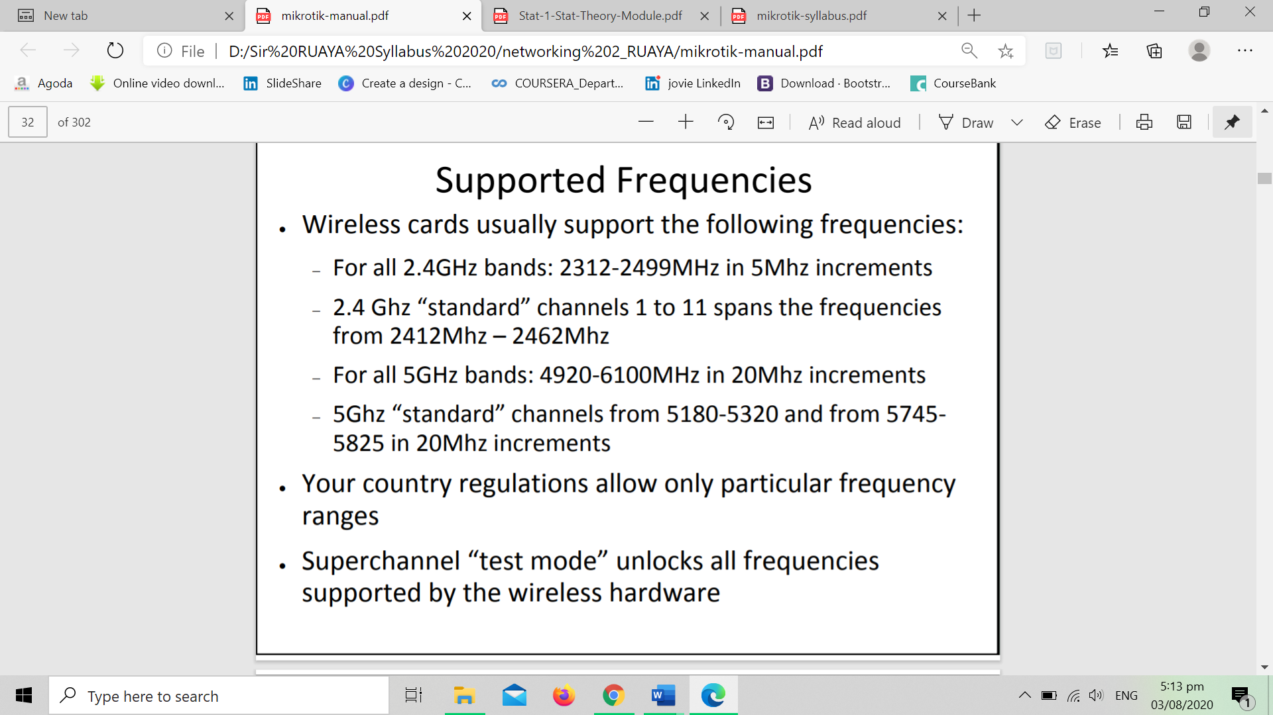

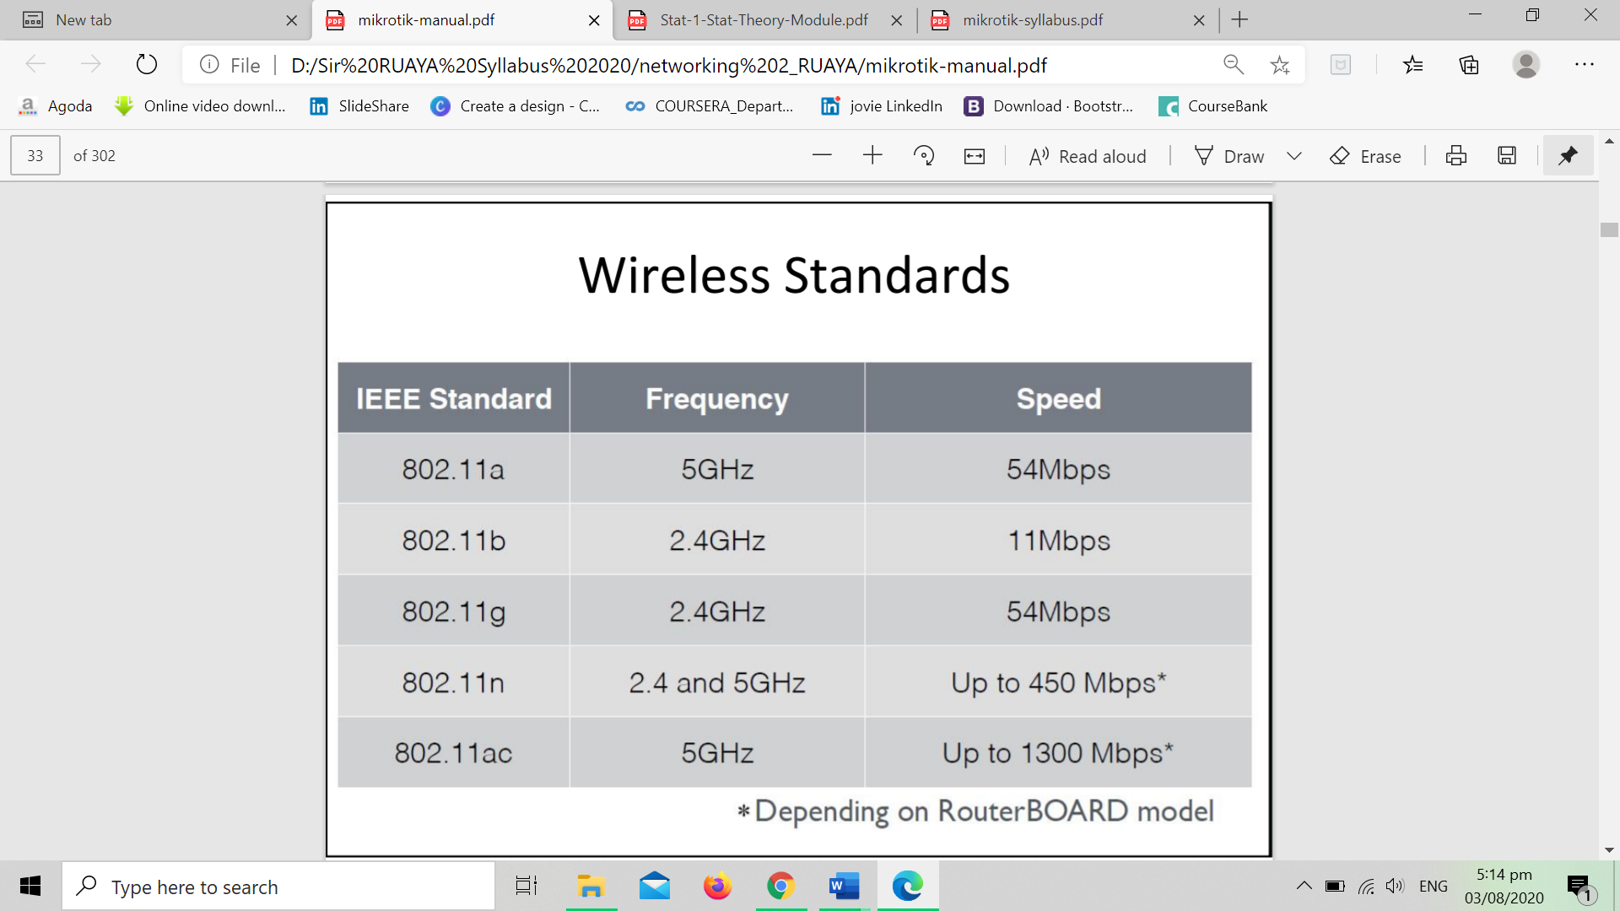

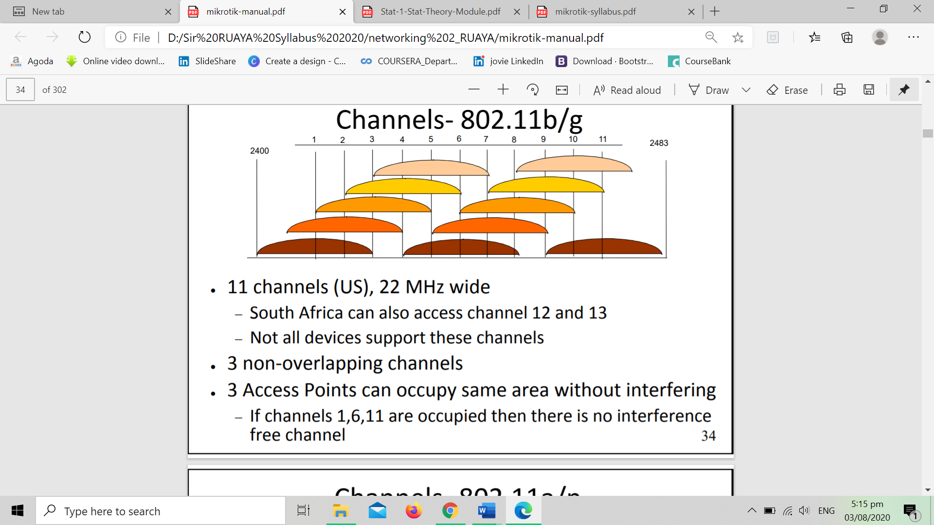

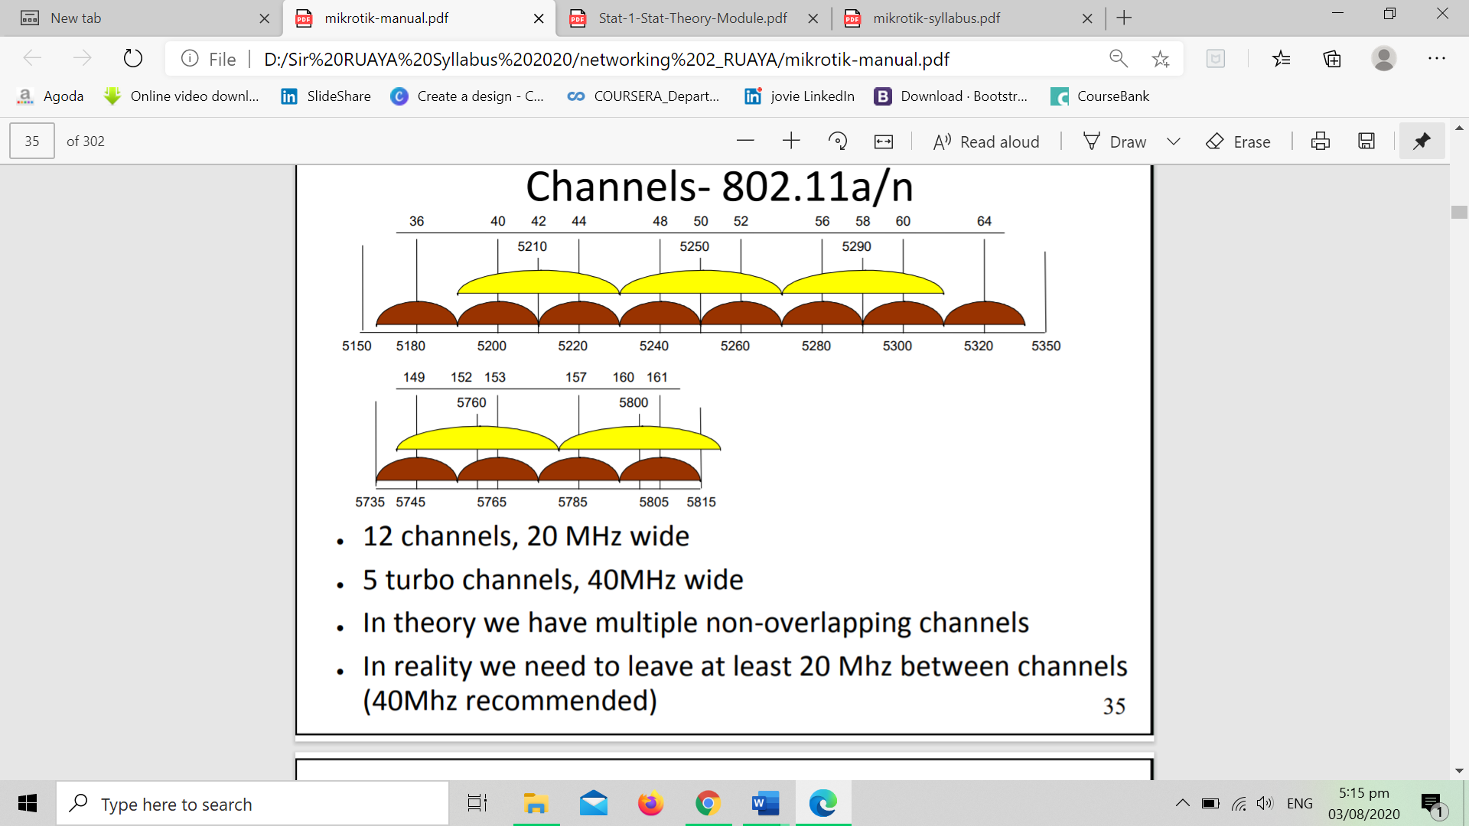

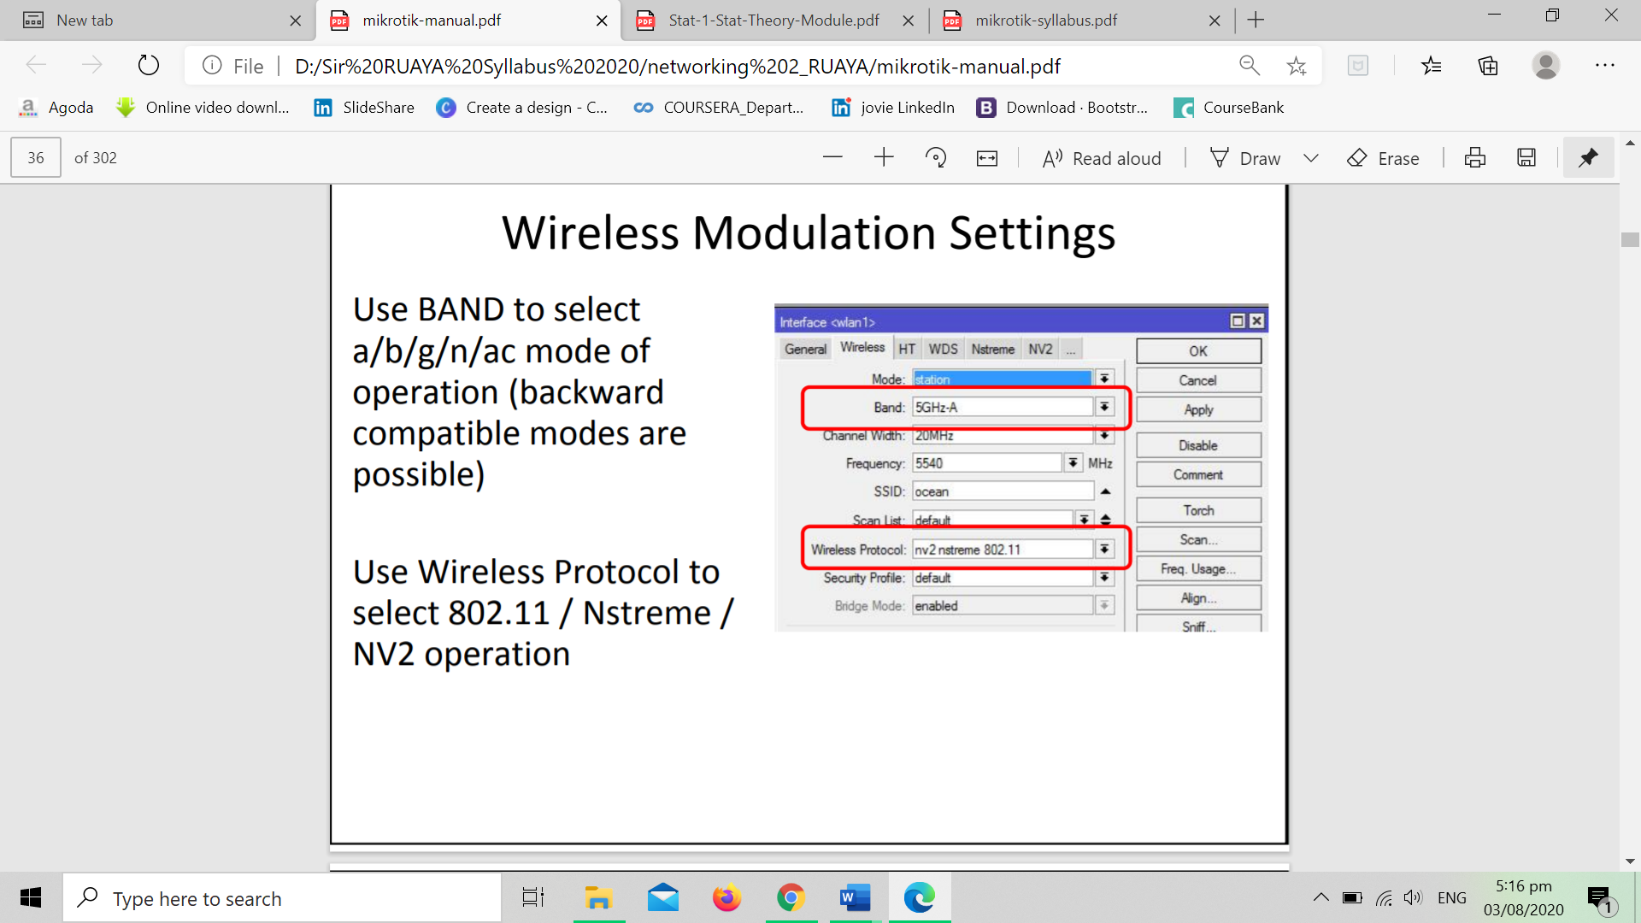

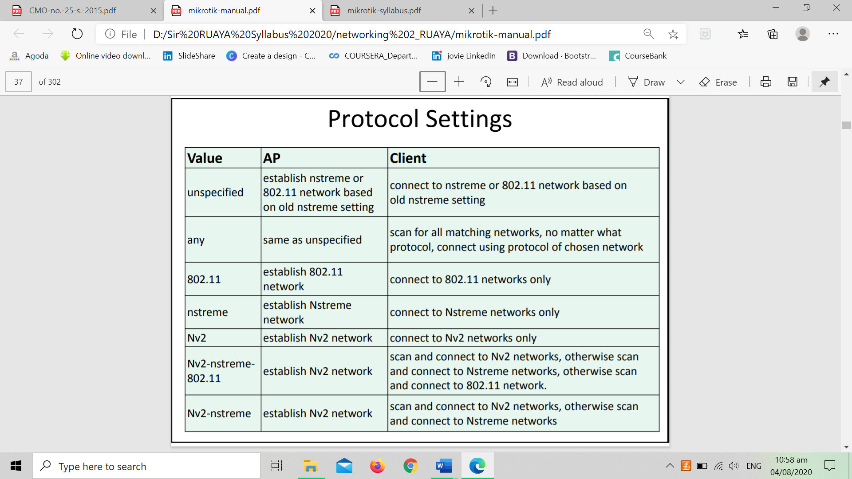

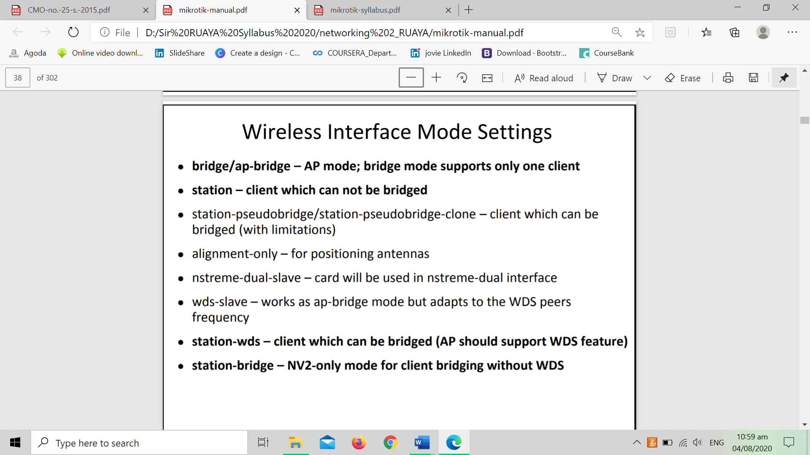

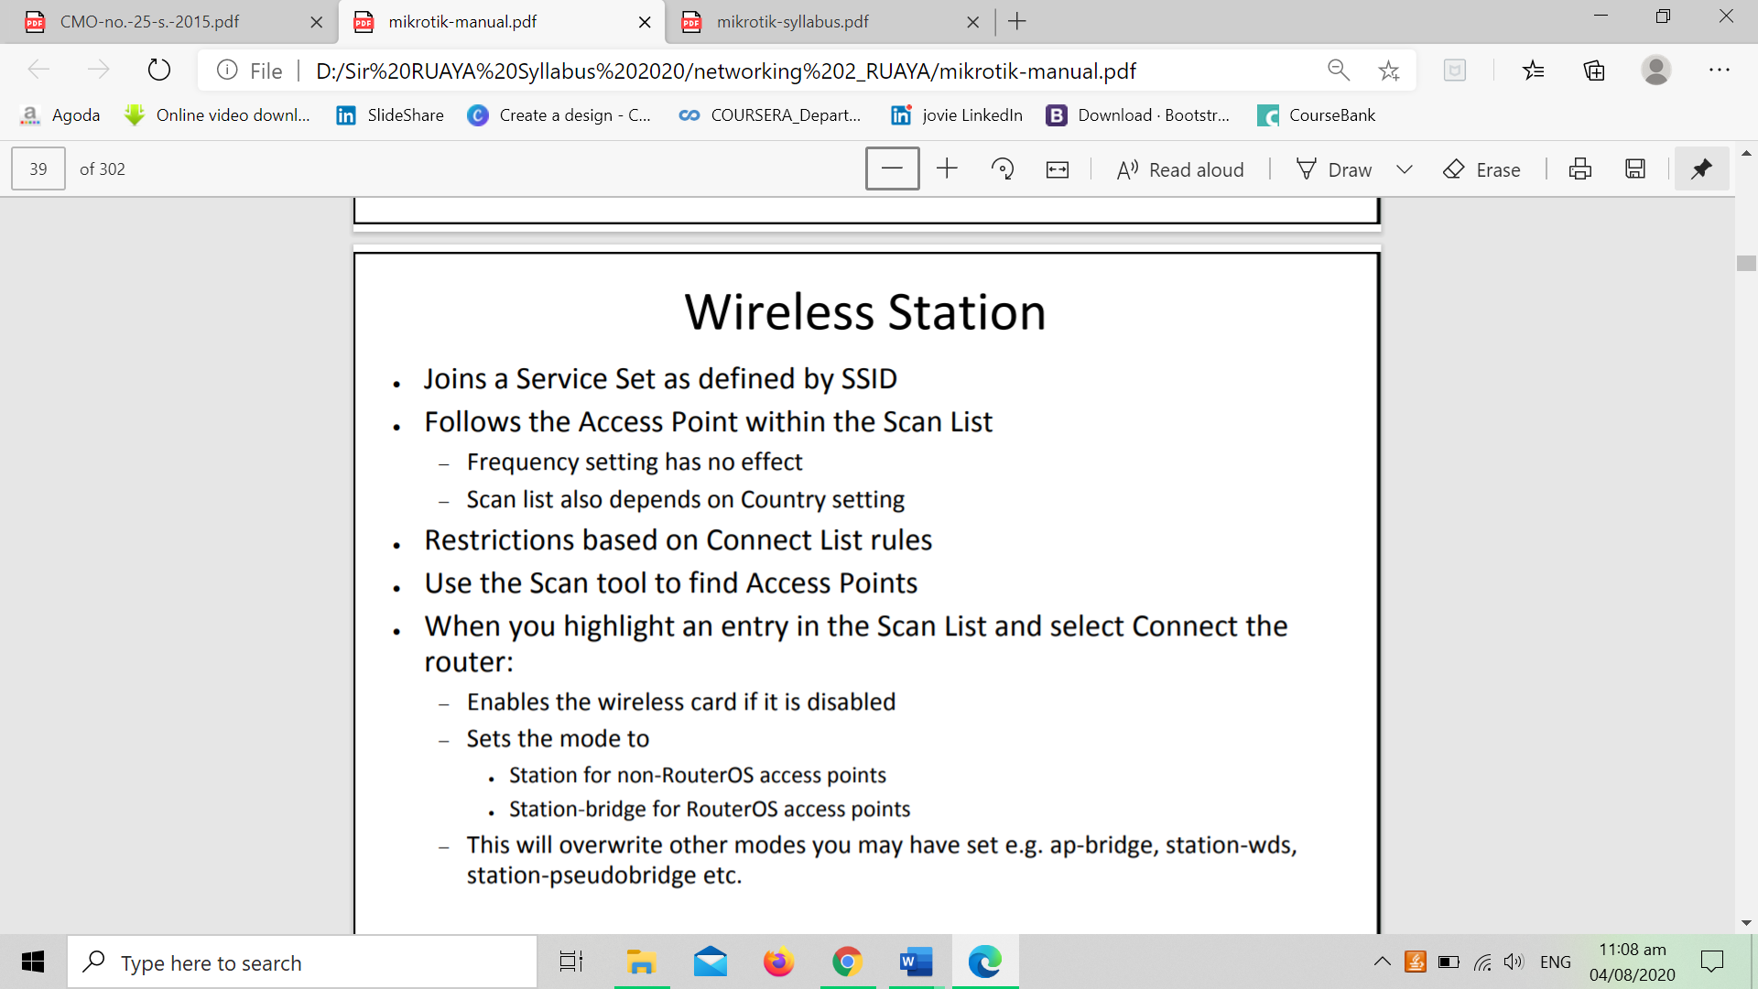

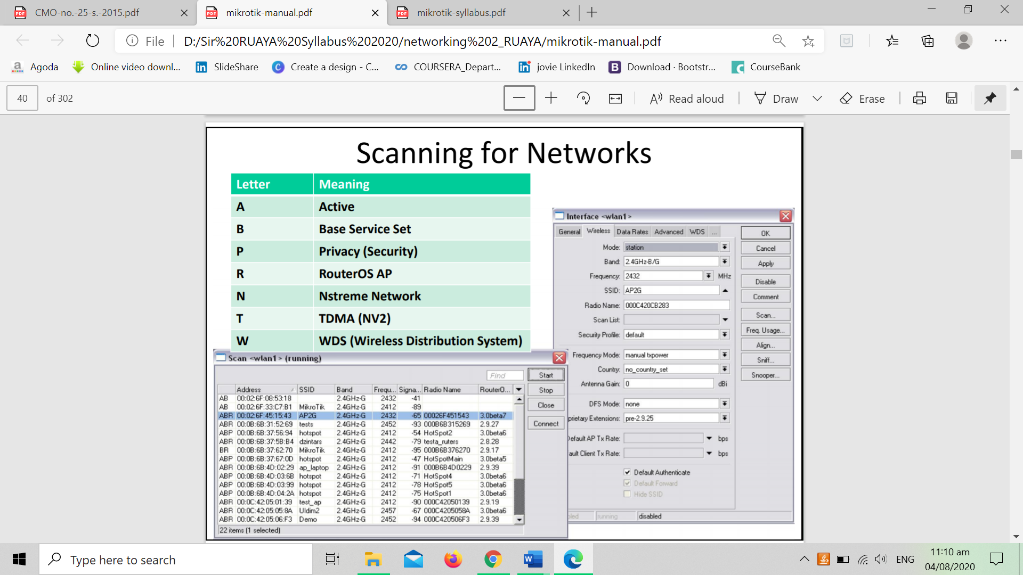

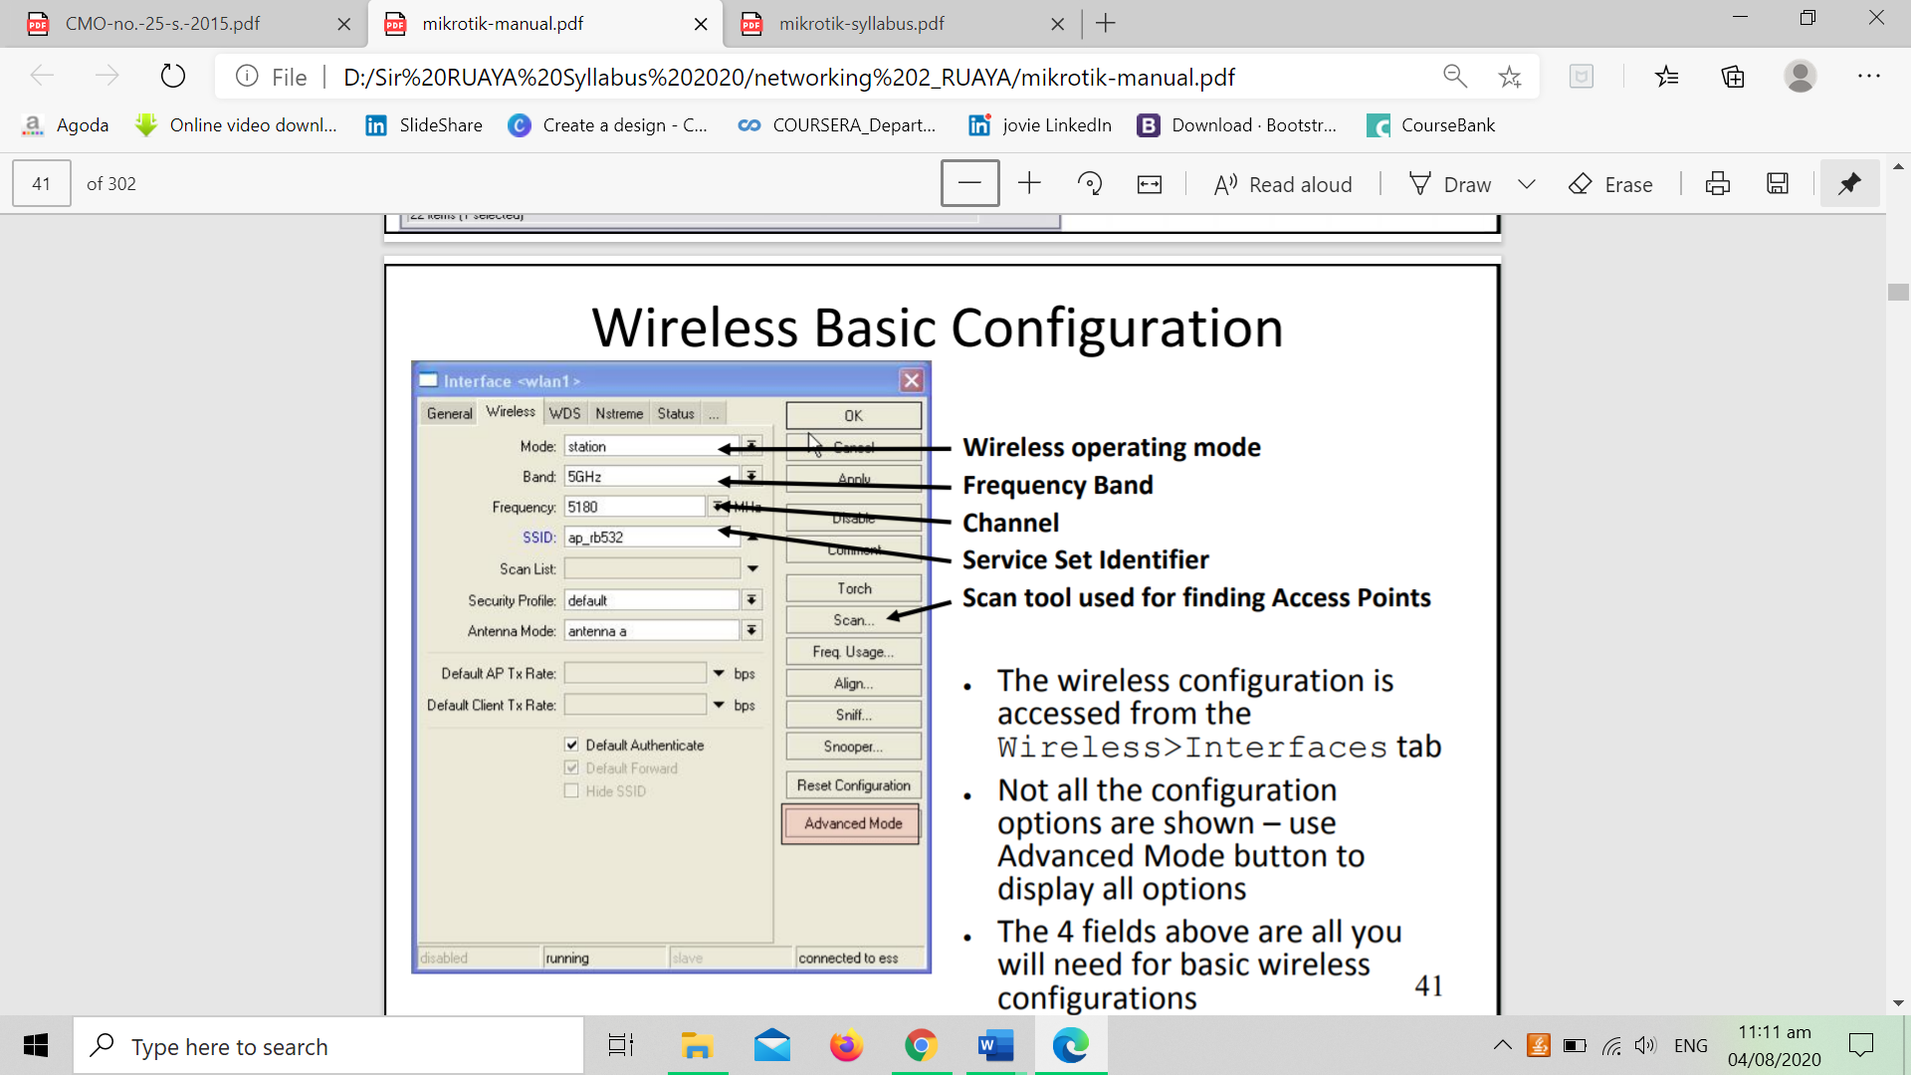

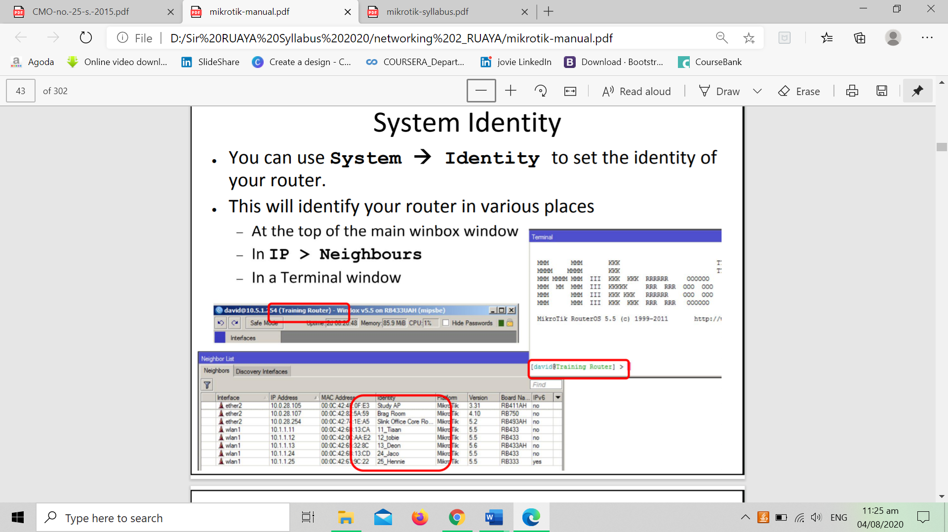

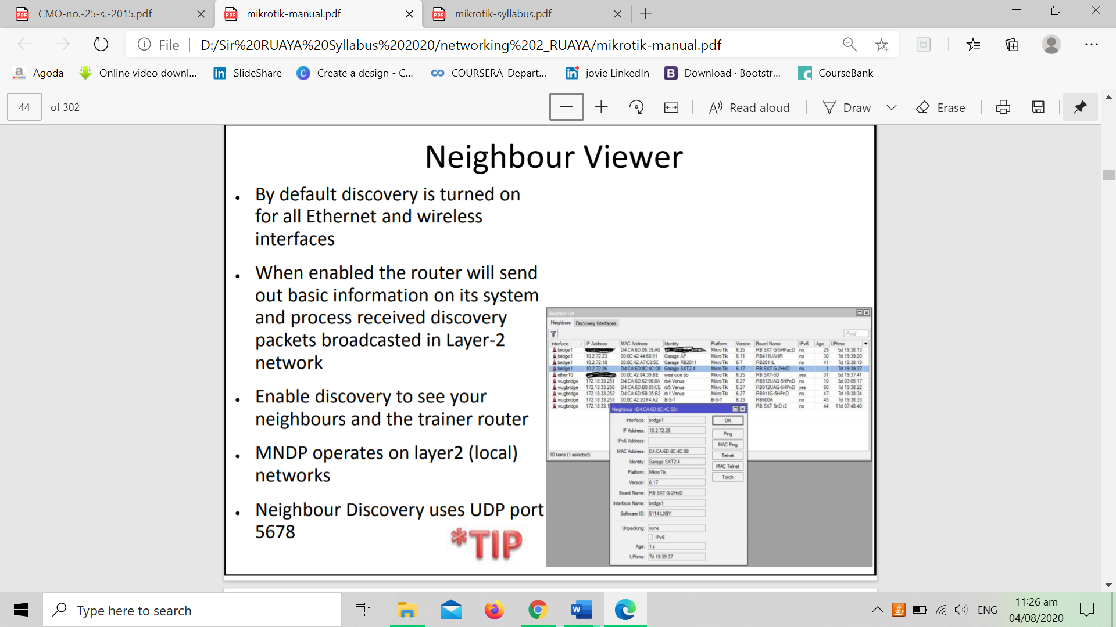

**V. Self-Evaluation**

1. What have you observed in setting up a managing RouterOS?

**VI. Review of Concept:**

**Configuring router**

Initial configuration has DHCP client on WAN interface (ether1), rest of the ports are considered your local network with DHCP server configured for automatic address configuration on client devices. To connect to the router you have to set your computer to accept DHCP settings and plug in the ethernet cable in one of the LAN ports (please check routerboard.com for port numbering of the product you own, or check front panel of the router).

Rubrics for Essay Test

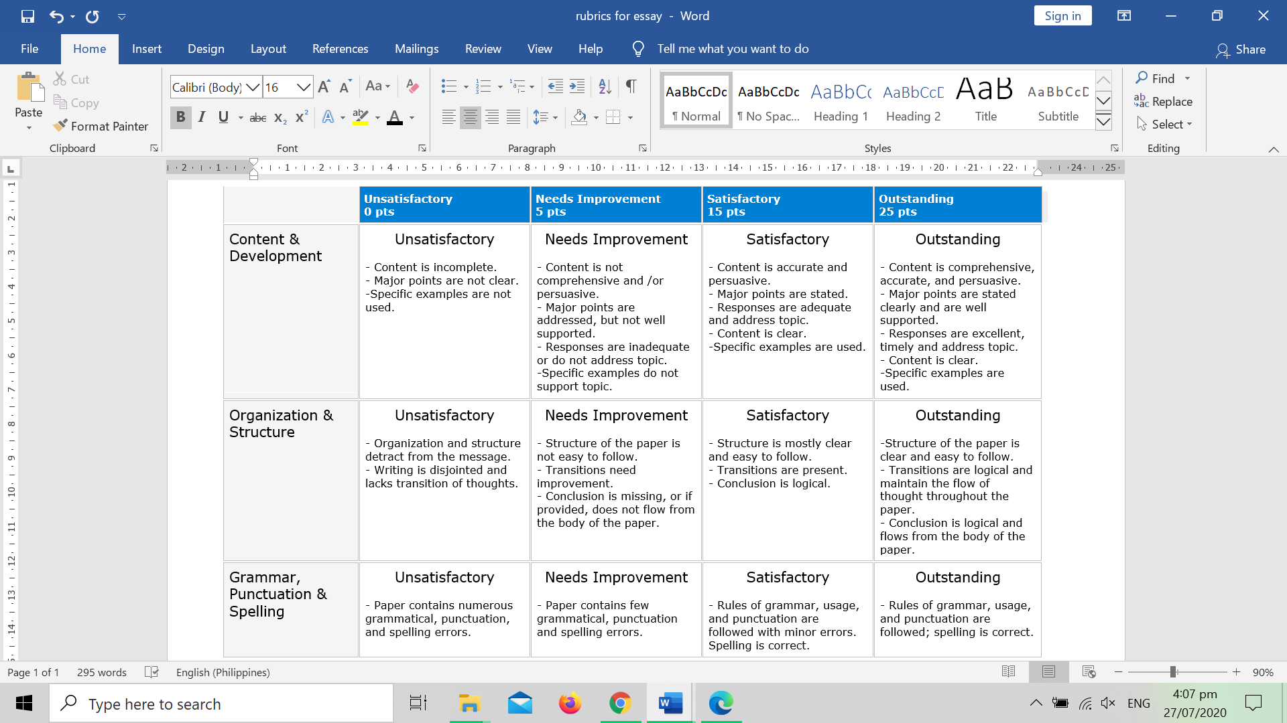

**VIII: References**

***Online***

* <https://help.mikrotik.com/docs/display/ROS/Command+Line+Interface>

***Books***

* Mastering Lowe, Doug (2018), Networking All-in-One For Dummies, 7 edition (25 May 2018)
* McMillan, Troy (2015)Cisco Networking Essentials, Sybex; 2 edition